AI Assisted Coding
Name : Omprakash.
HT No : 2303A52057
Batch No : 39
Task Description #1 (Syntax Errors – Missing Parentheses in Print
Statement)
Task: Provide a Python snippet with a missing parenthesis in a print
statement (e.g., print "Hello"). Use AI to detect and fix the syntax
error.
# Bug: Missing parentheses in print statement
def greet():
print "Hello, AI Debugging Lab!"
greet()
Requirements:
• Run the given code to observe the error.
• Apply AI suggestions to correct the syntax.
• Use at least 3 assert test cases to confirm the corrected code
works.
Expected Output #1:
• Corrected code with proper syntax and AI explanation.

Prompt :
#Act as a programming instructor: find the syntax error caused by the missing parentheses in the print statement, explain why it happens in Python 3, correct the code using best practices, and provide at least three assert test cases with expected output → def greet(): print "Hello, AI Debugging Lab!"; greet()

Code :
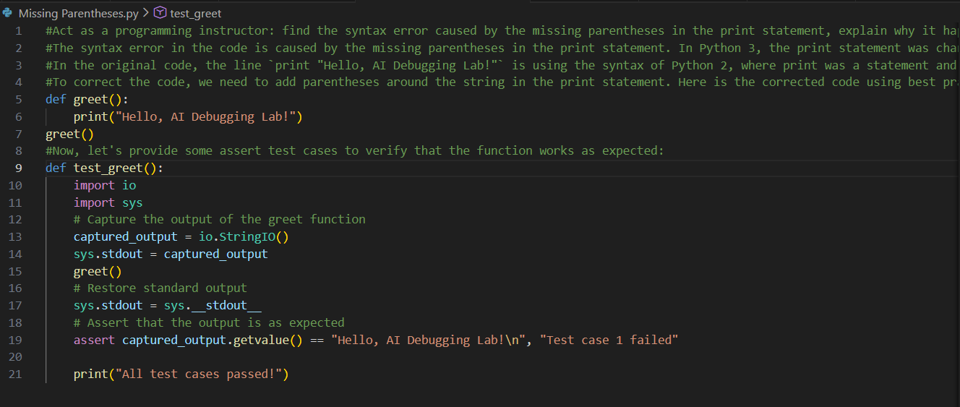
OUTPUT :
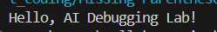

Task Description #2 (Incorrect condition in an If Statement)
Task: Supply a function where an if-condition mistakenly uses =
instead of ==. Let AI identify and fix the issue.
# Bug: Using assignment (=) instead of comparison (==)
def check_number(n):
if n = 10:
return "Ten"
else:
return "Not Ten"
Requirements:
• Ask AI to explain why this causes a bug.
• Correct the code and verify with 3 assert test cases.
Expected Output #2:
• Corrected code using == with explanation and successful test
execution.
Prompt :
#Act as a programming instructor: detect the bug caused by using assignment (=) instead of comparison (==) in the if condition, explain why it is wrong, correct the code using best practices, and provide at least three assert test cases with expected output → def check_number(n): if n = 10: return "Ten" else: return "Not Ten"

Code :
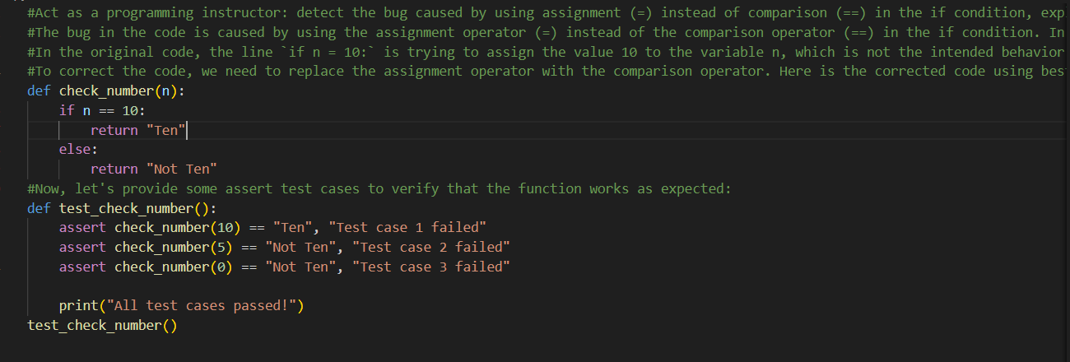
OUTPUT :
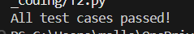
Task Description #3 (Runtime Error – File Not Found)
Task: Provide code that attempts to open a non-existent file and
crashes. Use AI to apply safe error handling.
# Bug: Program crashes if file is missing
def read_file(filename):
with open(filename, 'r') as f:
return f.read()
print(read_file("nonexistent.txt"))
Requirements:
• Implement a try-except block suggested by AI.
• Add a user-friendly error message.
• Test with at least 3 scenarios: file exists, file missing, invalid
path.
Expected Output #3:
• Safe file handling with exception management.

Prompt :
#Act as a programming instructor: explain the runtime error when the file is missing, rewrite the program using try-except with a user-friendly message, and provide tests for file exists, file missing, and invalid path along with expected output → def read_file(filename): with open(filename,'r') as f: return f.read(); print(read_file("nonexistent.txt"))

Code :
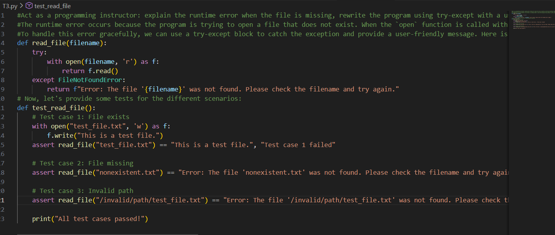
OUTPUT :
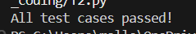

Task Description #4 (Calling a Non-Existent Method)
Task: Give a class where a non-existent method is called (e.g.,
obj.undefined_method()). Use AI to debug and fix.
# Bug: Calling an undefined method
class Car:
def start(self):
return "Car started"
my_car = Car()
print(my_car.drive()) # drive() is not defined
Requirements:
• Students must analyze whether to define the missing method
or correct the method call.
• Use 3 assert tests to confirm the corrected class works.
Expected Output #4:
• Corrected class with clear AI explanation.
Prompt :
#Act as a programming instructor: detect the error caused by calling an undefined method, explain why it occurs, decide whether to create the missing method or correct the method call, and provide the fixed class with at least three assert test cases and expected output → class Car: def start(self): return "Car started"; my_car = Car(); print(my_car.drive())
Code :
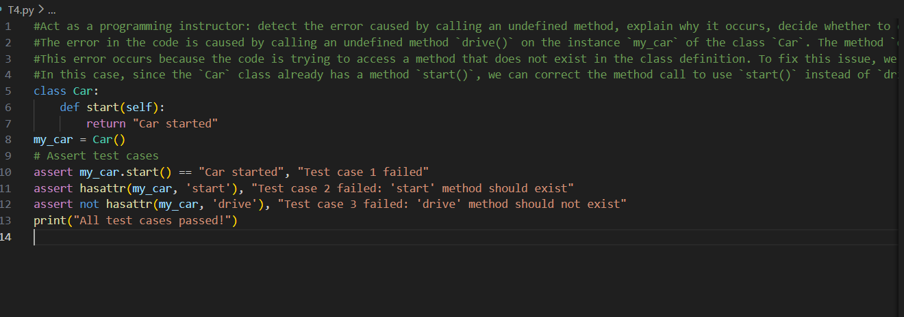
OUTPUT :
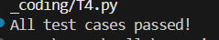
Task Description #5 (TypeError – Mixing Strings and Integers in
Addition)
Task: Provide code that adds an integer and string ("5" + 2) causing
a TypeError. Use AI to resolve the bug.
# Bug: TypeError due to mixing string and integer
def add_five(value):
return value + 5
print(add_five("10"))
Requirements:
• Ask AI for two solutions: type casting and string
concatenation.
• Validate with 3 assert test cases.
Expected Output #5:
• Corrected code that runs successfully for multiple inputs.
Prompt :
#Act as a programming instructor: explain why the TypeError occurs when adding a string and an integer, provide two fixes (type casting and string concatenation), and give corrected code with at least three assert test cases and expected output → def add_five(value): return value + 5; print(add_five("10"))

Code :
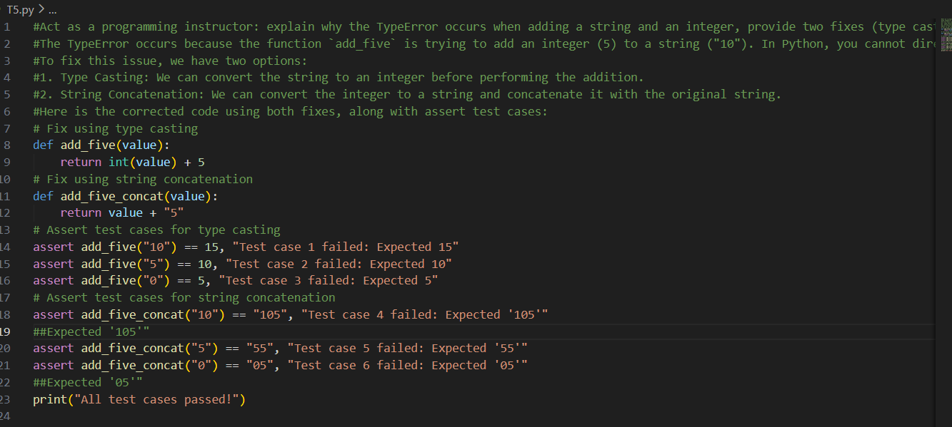
OUTPUT :
